Interview: Gary Wise Part 2
Toby Wachter
Tuesday, January 29, 2002
Part 1 of this interview can be found here.
Wachter: Some people on the Pro Tour seem to dislike you quite a bit. Why do you think that is?
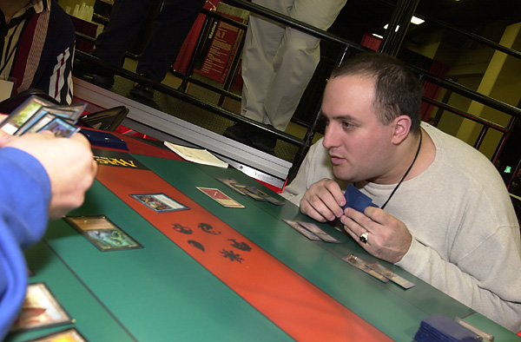
Wise: I think that one issue a lot of people have with me is the fact that I'm probably better known in the Magic community than my skill level would dictate. I think the mistake a lot of people make is to think that skill level is all that matters. One of the reasons I'm well known is that I'm very dedicated to the game. I've made myself a very visible and outspoken supporter of Magic as a whole, and at the same time, I've also made a point of making sure those who I feel are a detriment to the game are seen that way. I don't think there's anything wrong with someone who's not the best player in the game being one of the best known. I think that in the end, what's important is what's going to build the community to the point that Magic can become more respected by society as a whole.
Wachter: On that subject, there are some players that don't really care about the community. They show up to events, get their money, and leave. What do you think about people like that?
Wise: I think the money's important, because without the money, there wouldn't be a Pro Tour. I think you have to respect that the almighty dollar is at the base of this. There would be no Pro Tour if Wizards of the Coast didn't have a product that they felt the Pro Tour was helping to sell. So, it is a financially based institution. With that said, I think to go, get your money, and go home is a little shortsighted. If we all were to take the approach that had community involvement at a pinnacle, I think it would help the community to the point that the money would increase, along with the popularity of the game. As the game gets bigger, the money gets bigger. So, actually, those guys are hurting themselves. One thing that drives me in my approach of the game is the hope that one day Magic will be big enough that there will be sponsorships around... consistent sponsorships for all the top pros, and that making a good living as a Magic player will be a viable option even for those of us who aren't named Kai Budde. As long as guys are screwing the community, or saying, "screw the community", it's going to be a lot harder for that hope to become a reality.
Wachter: To be more specific, you've been attacked quite a bit recently by Peter Szigeti and Chris Benafel. Why do you think they've been acting this way?
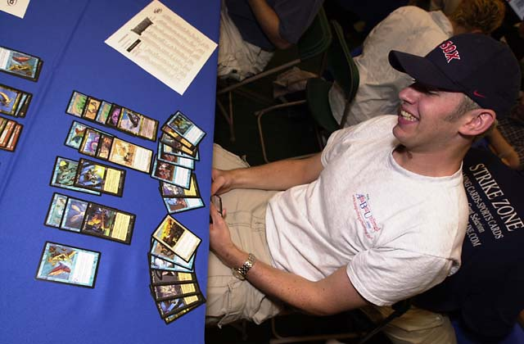
Wise: Peter Szigeti is a guy who wants to be Magic's villain. I'm not going to get into personal slanders because there are a lot that can be made about Peter. Quite frankly, it seems a bit beneath me to get involved with a guy who wants to call my mother fat. If he wants to get into particulars about me personally, then that's fine. I'll at least argue intelligently, but unfortunately Peter decided the more tactical approach would be to make jokes about my lineage, and it's just silly.
Chris Benafel, to be honest, I was kind of surprised by his Invitational report. Chris and I, at least in terms of face value have always gotten along decently. Chris' teammate Ryan Fuller and I don't get along very well. We have... let's call it professional differences. Chris, I would assume wants to be loyal to his friend and I admire that, but at the same time I think he went about doing it in a very stupid way. I think he's just shooting himself in the foot by doing it. If you anger the powers that be, the powers that be aren't going to be very happy with you, and I think that's what Chris has done. I just don't see why.
Wachter: Some people said it was unprofessional for you to use your column to take shots at Peter Szigeti. Do you feel that what you did was justified?
Wise: I don't think I really took shots at Peter, I told the story as it was. When Peter put up his website, I was annoyed, but I had a talk with him, and he actually took it down for a while. It may be back up now, but quite frankly I haven't cared enough to look. When he then wrote an introduction to a Steve O'Mahoney-Schwartz vs. Alan Comer Feature Match in the Grand Prix-Las Vegas coverage which took shots at me, I thought it would be best for me to try to explain the situation to the public so they knew to take what Peter was saying with a grain of salt. Sideboard, for a good reason, wants to keep personal feuds out of its forum, especially in a situation where I have a column and Peter doesn't. I could have said a lot of mean things, and a lot of insulting things about Peter, and I didn't. What I did do was tell the public, "Look, this is a guy who's obviously seeking a little bit of attention, and he's chosen me as a scapegoat for that. Take what he says with a grain of salt." That's the honest truth. I think that while it's not entirely professional to get involved with personal business, at the same time I think it's newsworthy when two professionals are feuding. So, I think it's my job to report on things like that. If there were someone else doing a column with content similar to Wise Words, they might be commenting on it. It's the fact that I'm the only one who really talks about that kind of stuff that made me feel obligated to say something about it.
Wachter: Some other people who don't like you, such as Jay Elarar and Ryan Fuller, have verbally attacked you during matches with personal insults. Why do you think people such as them are compelled to do this to you? Do you think there's a part of your personality that rubs people the wrong way, or do you think it's more a matter of them doing something unacceptable?
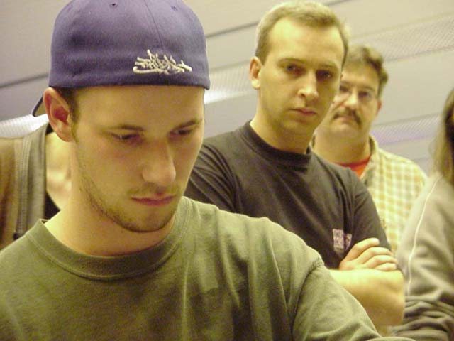
Ryan Fuller, who was suspended yesterday
Wise: I think that it's pretty obvious that I don't think much of Ryan, and Jay is basically mini-Ryan (laughs). They both entered the matches that you're talking about with the understanding that I have been emotional in the past, and still am to a certain extent... I've taken steps to try to avoid this now, to avoid those emotional explosions... but I am a bit of a hothead. They decided that the best strategy was to try and throw me off my game by sending me into a bit of an emotional fit. And you know what? In both cases it worked, and that's why I've taken steps to avoid reacting in that manner. I think that what they did goes outside not only the realm of good taste, but of good sportsmanship. I don't think the game should really be about that kind of thing. I would have liked to see punishments handed down to both of them for the way they behaved, because some of the things they were saying went so far above and beyond what should ever be said to any human being. Those matches were being watched by judges, and I think that they deserved to get at least warnings, more likely game losses and potentially disqualifications. Magic is supposed to be a fun game, and what they did was strip every ounce of fun out of it, in what quite frankly, were disgusting displays. I would hope that in the future, there might be some preventive measures to stop behavior like that on the Pro Tour.
Wachter: By showing that weakness, are you concerned that you might be inviting other players to do the same thing?
Wise: Absolutely, and I wouldn't be shocked if someone tried to do it. A Benafel, a Boeken or a Fuller, absolutely would try to do it. Note: Wise played against Boeken later at this Pro Tour, and both showed good sportsmanship. Fuller would do it again, and the others would try. I think that I would be more prepared for it now. When Jay did it, it was completely unexpected. Jay was a kid from Canada who I knew and had always spoken with at Pro Tours, and he made a decision. That decision was "Screw my friendship with Gary, I want the money. And I'm going to be as much of a jerk as humanly possible and hope that maybe that will work." And it did. But then again, he made the choice.
Wachter: I've actually heard people say that Jay really shouldn't have won that matchup. But, because he talked you out of your game, you lost.

I don't usually drink for the two weeks preceding a tournament, but I waived that rule before Barcelona...
Wise: That's absolutely true. There's more to that than just Jay. I went to that tournament very fatigued thanks to having way too good a time at Hampton Court Palace two weeks beforehand. I broke some personal rules in regards to tournament preparation. I don't usually drink for the two weeks preceding a tournament, but I waived that rule before Barcelona because I was having such a good time at Hampton Court Palace visiting the Ronaldsons. It definitely was reflected in my play. Regardless of the Elarar match, at that Pro Tour I was playing the worst Magic I've played in years. I went 5-8-1, and of those eight losses, I think I threw away about six of them. So, there was more to it than met the eye. But I absolutely should have won that match against Jay. In terms of playing Magic, I should have won that match. But, Jay won, so maybe I shouldn't have won that match. I don't know that I'm the person to say.
Wachter: There's been a lot of attention drawn to you recently, since you're close to falling off the gravy train. As a pro Magic player where tournaments make up a great deal of your income, is falling off the train something that worries you?
Wise: I was allowed to play in my first PTQs in over four years recently, in England. I entered the first one for the cost of five Pounds, which is about eight American Dollars, and I didn't do that well. Then I entered my second one for the same price, and won 500 Pounds by winning the PTQ. Now, that doesn't seem like such a bad deal to me! That is the equivalent of making Top 8 at a Grand Prix. Frankly, no offense to the English, I love England and I love the English Magic community and they have some good players there, but I think it's a lot easier to win a PTQ there than it is to finish Top 8 at your harder Grand Prix's. More important to me is the prestige involved. I have been on the gravy train for years and years. Pro Tour-New York 3 was when I got on, and I haven't fallen off since. That's four years now. Most Pro Tour players haven't been on the Tour for four years. To be on the gravy train for four years is an accomplishment I'm very proud of. I think it shows a certain standard of consistency that very few can match. That is one thing I've always stuck to, with regards to my career. I think it would be a shame if I fell off the gravy train, only because it's something I'm proud of. In terms of the money, it doesn't worry me. I made more in the PTQ then I've made on the Pro Tour this year because I've had a horrible season. So, that is not really a concern. If I get to a point where I have to keep going back to PTQs and winning 500 Pounds per, that doesn't seem so bad to me. Frankly, I'm making more out of the writing anyway.
Wachter: In the back of your mind somewhere, is there this idea that "Maybe I'll fall off the train and I won't be able to win a PTQ, and then what would I do with my life"?
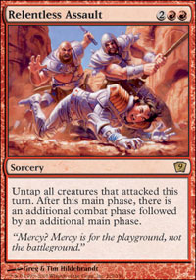
Wise: Well, if that were the case, I think I could do enough writing that I'd still be doing fine. But that's not the case because of the fact that I'm a very self-assured, confident person. It's just my way. Anyone who meets me can probably tell that's the way I am, I just come across that way. When I went into those PTQs, I went in with the mindset of "I know I'm going to win." That might sound cocky, but I think that's the mindset you really need to go into a PTQ with if you really want to succeed. You have to go into each match saying, "I'm going to beat the crap out of this guy. I'm a better player, I'm better prepared, and I'm just going to out-think him." Back when I was trying to qualify for the Pro Tour on a more consistent basis, before I was on the gravy train, I won five of my last nine Pro Tour Qualifiers just taking that attitude. I'd go into the bathroom, and slap myself in the face and stare myself down in the mirror and just tell myself "You are gonna beat the crap out of the next guy you play. You are just better than him. You are just going to crush him. He is going to be afraid of you, you are going to intimidate him, and you're going to come out of this match with three more points." And it worked. If nothing else, when I go to a PTQ now, unlike back then, I have a name that has built up over six years of Pro Tour play that is going to intimidate people. I think that's a huge advantage.
Wachter: As Sideboard's Limited expert, do you think there's more pressure on you because you have a reputation to keep intact?
Wise: I think that the only pressure I feel comes from myself. I think that any player worth a lick really should put pressure on themselves to do well, regardless of whether or not they're writing articles about Limited play. I started doing the Limited reviews because I thought it was something I could help people learn about. I didn't do it because of reputation or anything like that, I just felt like I knew it better than most, and others would improve if they got an alternative opinion. It's become somewhat of an institution I guess, so some people might see it or label it as what I see as definitive, but I don't think it's that way at all. I just think I'm a person who is pretty qualified to comment on the strengths and weaknesses of cards, and I'm just trying to help people out. I don't think it has anything to do with my performance. I try to help, regardless of if I do well, or if I do poorly.
Wachter: Do you think that falling off the train would cause you to lose credibility?
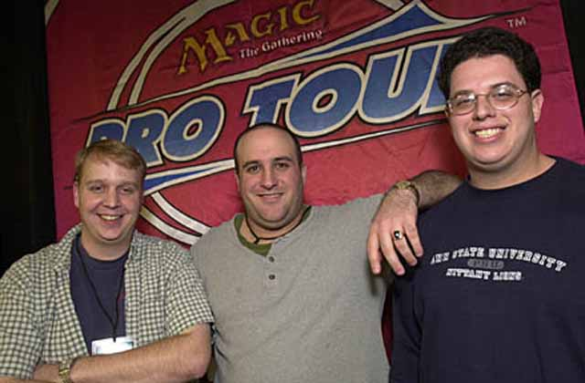
Gary, with 2000 Pro Tour-New York co-champions Scott Johns (left) and Mike Turian (right).
Wise: I think it would cause me to lose credibility in my mind. Anyone that's followed the Pro Tour closely can recognize that I haven't had a banner year, regardless of whether or not I make Top 48 at this tournament. I think that threshold is a lofty achievement, but the difference between a nineteen Pro Tour point and a twenty Pro Tour point player is nominal enough that it shouldn't really make a difference. If they're not paying close attention, then they won't know whether or not I'm on or off threshold, and it won't matter to them. They'll just keep reading the articles because they want to learn, and maybe I can help them do that. There are other writers, one who comes to mind specifically is Scott Wills, who do a really good job of previewing the sets. Scott is a former pro who just doesn't bother to go to Pro Tours these days. He's got other commitments. I don't think that anyone will learn less from reading his opinions now just because he's not bothering to show up half a world away to play Magic. That's not really a relevant part of learning how to play. I think that we all just sort of learn off one another, and if you gather enough opinions, then eventually you can form your own and do a little bit better.
Note: After this interview was conducted, Wise finished up Pro Tour San Diego in 12th place, keeping him on the gravy train.
Wachter: Why move to England? What went into that decision?
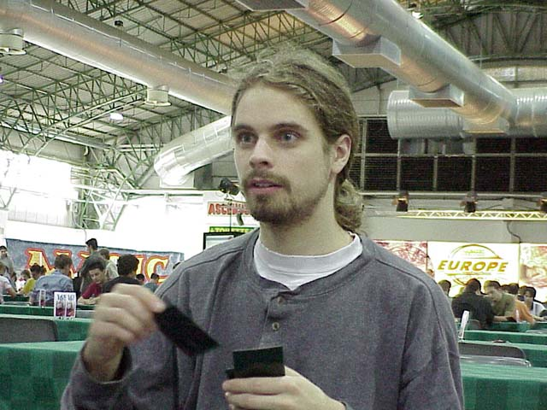
Gary's flatmate, Ben Ronaldson
Wise: As far as Magic goes, it was really difficult for me to playtest in Toronto, in part because I was on a team with people outside of Toronto. So therefore, I couldn't share information with those people in the city. That made it really difficult to have an ongoing relationship with Gab Tsang, Matt Vienneau, and so on. Matt and I also rub each other the wrong way sometimes. We're friends and get along really well 80% of the time, and the other 20% of the time we can't stand one another. That's because we both have very strong personalities. As a result, it can be really hard for us to exist simultaneously in the same place at the same time. So Magic in Toronto was difficult. I just wasn't playing enough to continue doing what I was doing. I felt that I owed it to myself to give it a better shot than just going to Pro Tours and playing on the internet every once in a while.
On top of that, Ben Ronaldson is a great guy. People on the Pro Tour know Ben, and they know that he's an amazing guy. He's charismatic and funny, and a lot of fun to hang out with. When he came to me and said, "Did you know I live in a palace, and we have a vacancy coming up?" I think as far as life experience goes, I would have been a fool to say no. Very few people with my accent get to live in Hampton Court Palace, or any palace. Every time I walk down the path either towards or away from the structure, I turn around and just thank God that I've gotten the opportunity that I have. I think that if anyone who, like me, doesn't have responsibilities that are going to bind them to a place gets an opportunity like the one I got, they owe it to themselves to give it a shot.
Wachter: Do you see yourself living there five years down the line?
Wise: Five years is a stretch. As much as the entire family has taken me in and treated me as one of their own, five years is a long time, and I'm definitely not looking that far ahead. I'm not living one day at a time, I do think I'll be there for a while yet, but five years... a lot can happen in five years to change things.
Wachter: Well, five years is just a number I used as an example.
Wise: Yeah, I know. Will I be there five months from now? I would say it is very likely. Ben and I are doing some good testing and we play off each other well, and we enjoy hanging out with one another, so it's a lot of fun. I should also mention, it's not just Ben and I. His older brother Ivan who is also a gamer lives with us, and Ivan is a madman. He's the English king of excess, and he would be insistent on my calling him that. We do have a lot of fun, and I'm learning a lot about what it is to live in a place other than North America and that has actually really opened my eyes to a lot of things.
Wachter: What are some of the cultural differences between Canada and England, in both normal aspects of life and Magic?

American society takes somewhat of a "might makes right" and every man for himself attitude, while the English community seems to be a little bit more community based.
Wise: In Magic the one thing I've really noticed is that the PTQ players share information with one another. They'll ask each other "What are you going to play?" and "What should I do with this deck?" and so on. In Toronto, and this is the way I would expect it to work, and maybe that's because I was raised in the Toronto community... but you'll have bands of players who will be very secretive, keeping their information to themselves. They'll test within their little group, and then show up to PTQs and compete. In England, there are "teams", but those teams... like Ben might go to Scott Wills and say, "So what are you playing in the PTQ?" And it's just really interesting that the players are a lot more open about it. I think that's a bit of a reflection on society too. North American society takes somewhat of a "might makes right" and every man for himself attitude, while the English community seems to be a little bit more community based. It's not so much about the individual as much as it's about everyone's happiness. That's a really positive attribute of that community.
Outside of Magic? Just lots of little things. Different words have different meanings. Like I told Ben I used to wear suspenders and he started laughing, and I asked why. He informed me that suspenders are what we consider to be garter belts. So we had a laugh over that. The pub for example, is completely different there than over here. Here it's like you go out until two in the morning getting drunk only with people over the age of 21. While there, the whole family goes to the pub and mom and dad drink while the kids run around. It's a different atmosphere. It's pretty costly. England is possibly the most expensive country in the world. I don't know of one that's more expensive, but it's a lot of fun there too. Things aren't done for show as much. You don't make a movie theater five million square feet, you make it just big enough for people to go see a movie. That's the British attitude. They don't like excess.
Wachter: What's your average day like now in England living in Hampton Court Palace, as opposed to Canada?
Wise: My average day in England is pretty laid back. It's basically, wake up later than your average nine-to-five professional, do some writing, play some Magic Online, check my email, stuff like that. Ben and Ivan each work an eight hour shift each day, where one will work nine-to-five, and the other will work two-to-ten, and then they'll alternate each day. So, as a result I only have three hours in the apartment to myself, and that's my writing time. Once one of them is off, quite often it will lead to a movie, or going to the pub, or so on. When Ben is done with work at night, we'll usually do some playtesting, or we'll host a draft. We'll have some of England's better drafters come down and hang out at the palace.
Wachter: What are your predictions for the future of your Magic career?
Wise: I think you're going to see me take more of a backseat as a player. To be honest I think this is a young person's game, and as I get older... you notice that Magic players get really good at around sixteen or seventeen. It's really hard to keep up when you're 28 years old. Honestly, the brain doesn't work as fast as it once did. You don't function as well without sleep, which is a major issue at Pro Tours. I'll keep playing the game, I love the game and I wouldn't be doing this stuff if I didn't love the game. But I don't know that I can keep up with the Ben Rubins and the Kamiel Cornelissens of the world, and I don't know that I ever have. I think there have been times where it's possible that I've been in the top 25 players in the world, and I don't think I am now. I think that's indicative of the fact that the competition may be getting fiercer. For me to say that I'm going to get awesome again, or awesome for the first time even, may not be that realistic. But I'm going to try my best, and I think I'm definitely capable of hitting Top 8 at a Limited Pro Tour. I've got eight Limited Top 32s or something ridiculous like that, and at any one of those tournaments if I get one more good mana draw, then I can make Top 8. So anything's possible.

